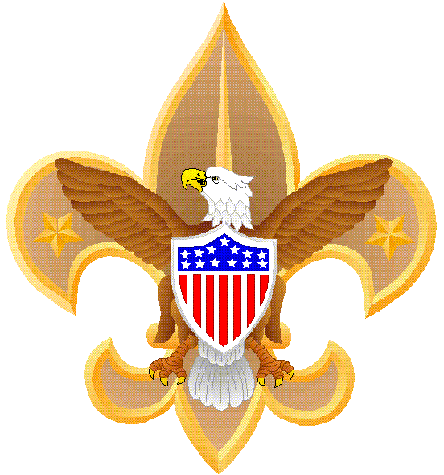
BSA TROOP 1

“GOOD TURN” SERVICE PROJECT
----------------------------------------------------------------------------------------------------------------------------------------------------------------------------------------------------------
JOIN US Saturday, September 10th

On the Harry E. Kinney CIVIC PLAZA
As WE Support the Alzheimer’s Association

New Mexico Chapter…
AS THEY WALK WITH A PURPOSE TO
MOVE OUR COMMUNITY TO
END ALZHEIMER’S!!

DETAILS…
WHAT: Troop 1 will help with the set-up, help lay down the walking course and tear down after the event.
Also wearing the lizzie costume

WHEN and WHERE: Meet at the Scout Hut at 6:30 am
Service Times…7:00 am to 11:00 am

TRANSPORTATION: We will carpool from the Scout Hut,
returning back to the Scout Hut by 11:30 am

WHAT TO WEAR: TROOP 1 T-SHIRTS WITH SCOUT SHORTS OR TAN/KHAKI SHORTS… PLEASE!!!
Don’t forget a hat and sunscreen and maybe a snack!

ADULT EVENTMASTER: Mr. Jerry Karasz, 615-8802 (cell)

